**PROXY LETTER**

**Date:** 04/21/2025

To Whom It May Concern,

eThekwini Municipality

Business Licensing Department

I, **Thato Morake**, the undersigned Director of **Parables and Platters (Registration Number: 2025 / 094299 / 07)**, hereby appoint **Philani Kemele** as my representative to act on behalf of **Parables and Platters** in all matters relating to the application, submission, and management of our business license with the **eThekwini Municipality**.

This proxy includes the authority to submit all necessary documents, complete forms, make payments, and liaise with municipal authorities on behalf of the company, as required for obtaining the business license.

**Parables and Platters** is a private company, registered on **February 2, 2025**, and is in business under registration number **2025 / 094299 / 07**. Philani Kemele is authorized to act in all capacities necessary for this process.

The proxy is granted with effect from the date of this letter and remains in effect until further notice or the completion of the business licensing process.

Should you require any further confirmation or clarification, please do not hesitate to contact me directly at **061 554 9064**.

Thank you for your attention to this matter.

**Signed:** 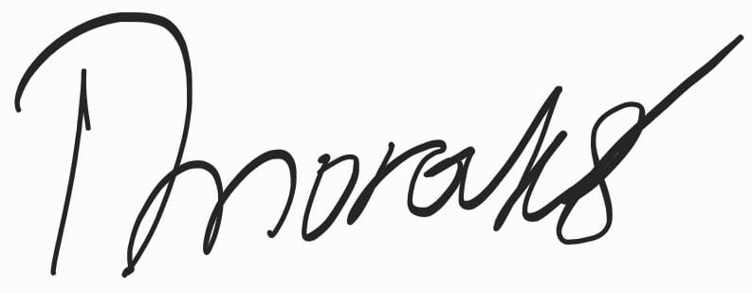

**Thato Morake**

Director, **Parables and Platters**

Date: 04/21/2025

**Authorized Representative:**

**Philani Kemele**

Representative, **Parables and Platters**

Date: 04/21/2025

Signature: